Bisection :-

f[x_]:=x^3-5x+1;

Plot[f[x],{x,-3,3}]

f[x_]:=x^3-5x+1

a[0]=0;

b[0]=1;

Do[p[n+1]=N[(a[n]+b[n])/2];

If[N[f[a[n]]*f[p[n+1]]]<0,a[n+1]=a[n];

b[n+1]=p[n+1],a[n+1]=p[n+1];

b[n+1]=b[n]],{n,0,20}]

Print[“n”,”a[n]”,”b[n]”,”p[n+1]”]

TableForm[Table[{n,a[n],b[n],p[n+1],f[p[n+1]]},{n,0,20}]]

Regular Falsi :-

Do[p[n+1]=b[n]-((b[n]-a[n])/(f[b[n]]-f[a[n]]))*f[b[n]];

If[N[f[a[n]]*f[p[n+1]]]<0,a[n+1]=a[n];

b[n+1]=p[n+1],a[n+1]=p[n+1];

b[n+1]=b[n],{n,0,20}]

Print[“n”,”a[n]”,”b[n]”,”p[n+1]”]

TableForm[Table[{n,a[n],b[n],p[n+1],f[p[n+1]]},{n,0,20}]]

Secant Method :-

Do[a[n+2]=a[n+1]-(a[n+1]-a[n])/(f[a[n+1]]-f[a[n]]) f[a[n+1]],{n,0,9}]

TableForm[Table[{n,a[n],f[a[n]]},{n,0,9}]]

Newton Raphson Method :-

f[x_]=x^3+3x+2

Plot[f[x],{x,-3,3}]

a[0]=-0.5;

Do[a[n+1]=a[n]-((f[a[n]]/f’[a[n]]),{n,0,9}]

TableForm[Table[{n,a[n],f[a[n]]},{n,0,9}]]

Gauss Jordan :-

MatrixForm[A = {{3.0, -12.0, 5.0}, {-3.0, -1.0, 3.0}, {2.0, 2.0, -10.0}}]  
MatrixForm[B = {6.0, 2.0, 7.0}]  
lie1 = A.{x1, x2, x3} == B

Solve[lie1, {x1, x2, x3}]

LinearSolve[A, B]

MatrixForm[A = {{3.0, -12.0, 5.0}, {-3.0, -1.0, 3.0}, {2.0, 2.0, -10.0}}]  
MatrixForm[B = {6.0, 2.0, 7.0}];  
MatrixForm[aug1 = Transpose[Join[Transpose[A], {B}]]]  
MatrixForm[r = RowReduce[aug1]]  
x = r[[All, 4]]

MatrixForm[g1 = UpperTriangularize[aug1]]

MatrixForm[A = {{4.0, 3.0, 2.0}, {2.0, -11.0, 6.0}, {1.0, 2.0, -10.0}}]  
MatrixForm[B = {4.0, 2.0, 7.0}]  
lie1 = A.{Subscript[x, 1], Subscript[x, 2], Subscript[x, 3]} == B

Gauss-Seidel :-

A = {{4.0, 1.0, 2.0}, {-3.0, 5.0, 1.0}, {1.0, 1.0, 3.0}};  
d = {{4.0, 0, 0}, {0, 5.0, 0}, {0, 0, 3.0}};  
u = {{0, 1.0, 2.0}, {0, 0, 1.0}, {0, 0, 1.0 }};  
l= {{0, 0, 0}, {-3.0, 0, 0}, {1.0, 1.0, 0}};  
b = Transpose[{{4.0, 7.0, 3.0}}];  
  x[1]=Transpose[{{0, 0, 0}}];  
 Do[x[n+ 1] = LinearSolve[(l + d), -u.x[n]+b];  
 Print[x^n, "=", MatrixForm[x[n]]], {n, 1, 15}]

Gauss Jacobi :-

A = {{3.0, 1.0, 2.0}, {-3.0, 5.0, 1.0}, {1.0, 1.0, 3.0}};  
d = {{3.0, 0, 0}, {0, 5.0, 0}, {0, 0, 3.0}};  
u = {{0, 1.0, 2.0}, {0, 0, 1.0}, {0, 0, 0}};  
l = {{0, 0, 0}, {-3.0, 0, 0}, {1.0, 1.0, 0}};  
b= Transpose[{{3.0, 7.0, 3.0}}];  
x[1]= Transpose[{{0, 0, 0}}];   
Do[x[n+ 1] = LinearSolve[d, -(l+u).x[n]+b];  
Print[x^n, "=", MatrixForm[x[n]]], {n, 1, 15}]

Lagrange :-

y={1,2,3,10,11};  
f={2,5,10,20,3};  
n=Length[y];  
n=Length[f];  
i=1;  
While[i<=n,L[i,x_]=(Product[(x-y[[j]])/(y[[i]]-y[[j]]),{j,j=1,i-1}])*(Product[(x-y[[j]])/(y[[i]]-y[[j]]),{j,j=i+1,n}]);i++];  
Lagrange[x_]=Sum[(L[k,x]*f[[k]]),{k,k=1,n}];  
g=Simplify[N[Lagrange[x]]];

Newton Interpolating :-

y={0,1,3};  
f={1,3,55};  
n=Length[y];  
n=Length[f];  
dd[n_]:=Sum[(f[[i]])/((Product[(y[[i]]-y[[j]]),{j,j=1,i-1}])(Product[(y[[i]]-y[[j]]),{j,j=1,i-1}])),{i,1,n}]  
p[x_]=Sum[(dd[i]*Product[If[i<=j,1,x-y[[j]]],{j,1,i-1}]),{i,1,n}]  
Print["Newton Polynomial =",p[x]]  
Print["Simplified Newton Polynomial =",Simplify[p[x]]]

Trapezoidal :-

f[x_]:=(x^2)/(1+x+x^3)  
a=1.0  
b=2.0  
Ap=((b-a)/2)*(f(a)+f[b])  
Exacti=N[Integrate[((x^2)/(1+x+x^3)),{i,1,2}]]  
Abserr=Abs[Ap-Exacti]

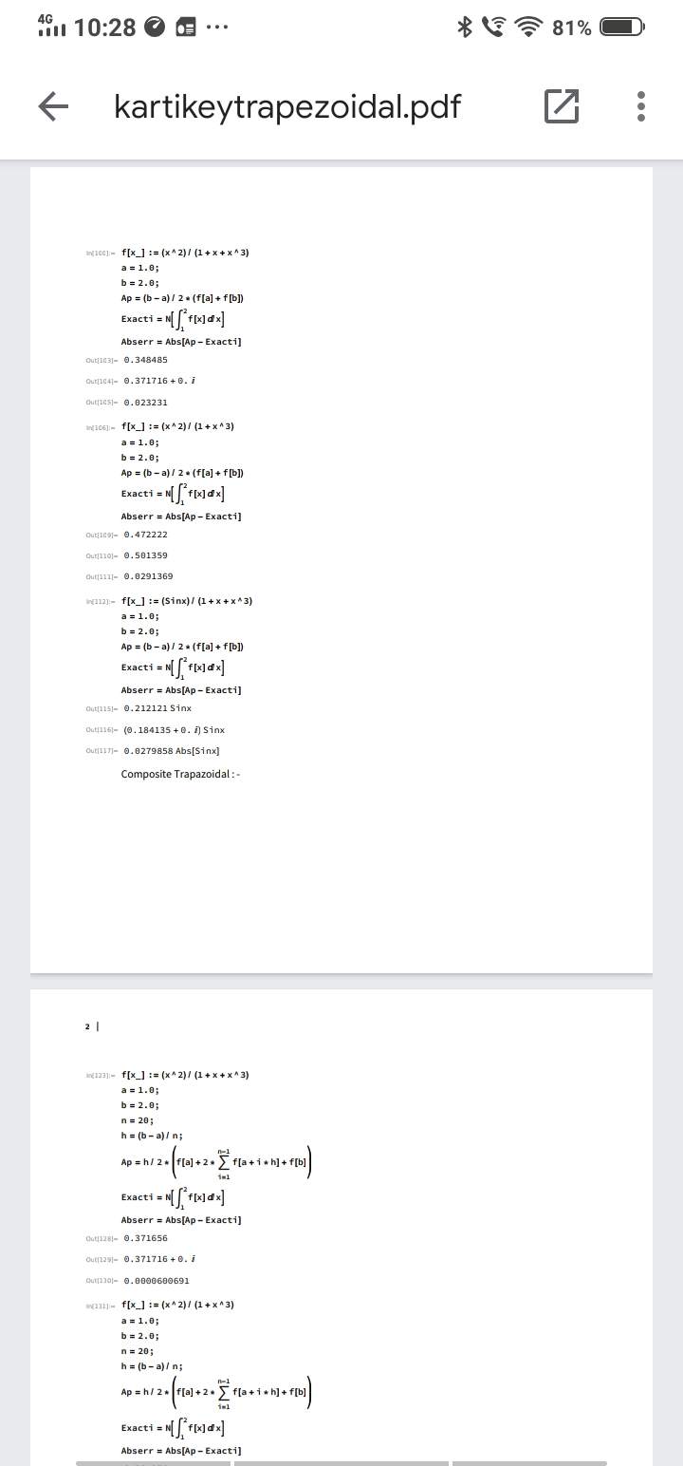

Composite Trapezoidal :-

f[x_]:=(x^2)/(1+x+x^3)  
a=1.0;  
b=2.0;  
n=20;  
h=(b-a)/n;  
ap=h/2*(f(a)+2*Sum[f[a+i*h]+f[b],{i,1,n-1}])  
exacti=N[Integrate[f[x],{x,1,2}]]  
abserr=abs[ap-exacti]



Simpsons :-

d[x_]:=1/(1+x);  
m=12;  
a=0;  
b=1;  
n=m/2;  
h=(b-a)/m;  
APPINT=N[h/3((f[a]+f[b])+2*Sum[f[a+(2k)*h],{k,1,m-1}]+4*Sum[f[a+(2k-1)*h],{k,1,m}])];  
EXACTINT=N[Integrate[d[x],{x,0,1}]];  
Error=Abs[APPINT-EXACTINT];  
Print["APPINT=",APPINT]  
Print["Exactint=",EXACTINT]  
Print["Error=",Error]

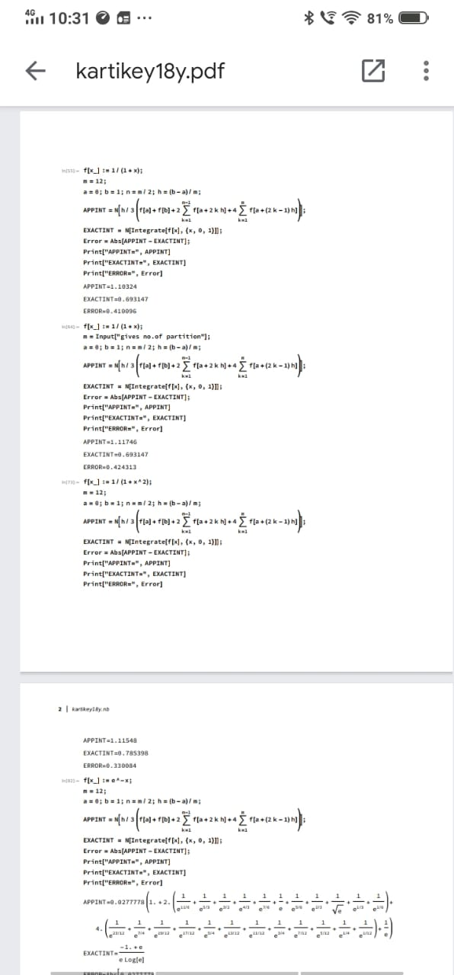

Euler :-

ExactSol= DSolve[{y'[x]==x+y[x],y[0]==1.0},y[x],x]  
L[x_,y_]:=x+y  
n=10;  
a=0.0;  
b=1.0;  
h=(b-a)/n;  
y[0]=1.0;  
y0=y[0];  
For[i=0,i<=n-1,i++,z[i]=a+i*h;  
y[i]=y0;  
y[i+1]=y[i]+h*L[y[i],y[i]];  
Print["The",i+1,"Approx. vause is ",y[i+1]];  
y0=y[i+1]];

